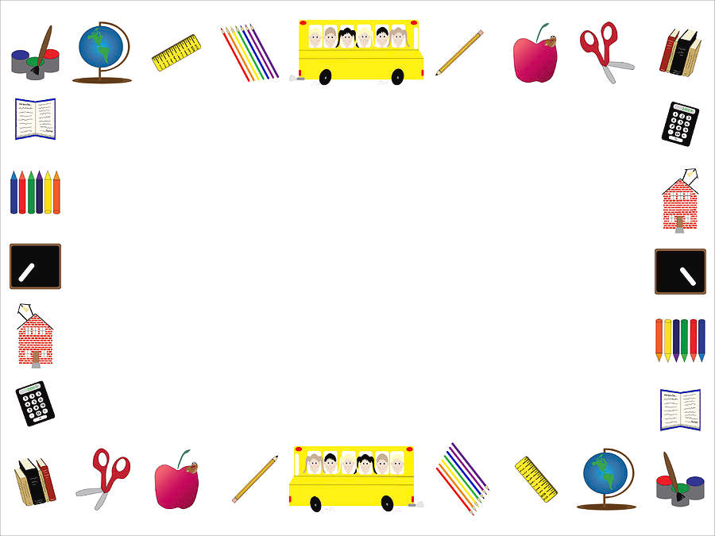

Second Grade Supply List

2025-2026

* $20 for Field Trips and Activities (if you can do more to sponsor another child that is greatly appreciated)
* Hand Sanitizer 12fl oz or larger (to share with the class)
* Headphones NOT ear buds (just for your child to use)
* Reusable Water Bottle (just for your child to use)
* Kleenex (to share with the class)
* Clorox wipes (to share with the class)
* Pencil box (just for your child to use)
* Washable water colors paint set (8 colors-for your child to use)
* Kid scissors (for your child to use)
* Fun Band-Aids (to share with the class)
* 20 Individually wrapped crackers/pretzels to share with the class

\*Please label all items that are for your child only

Thank you!